BOF
course also online
https://www.cs.ubbcluj.ro/~rlupsa/edu/pdp/

LECTURE W1
multithreaded programming - google images

concurrent = several tasks that are in progress at the same time, not completely independent
switching tasks is problematic
??? core pins

parallel =

distributed = higher cost of communication,

1970' -> 1Mhz
1999 -> 4Ghz
now it is the same, because increasing the freq would lead to too much heat

time to do addition operation = depends on the distance from the input to the output, through the transistors

processor pipeline - starting the next operation when the current is still on-going

"there's no cloud, there's only someone else's computer"

miracle on the hot?? - dual engine failure
4-engine plane flew through a volcano ash cloud and all 4 engines failed
arian 5 because of a programming mistake

why not:
race condition - needs serialization w.r.t. the shared resource

spectrum & meltdown security issues

getting rid of race conditions - mutexes

deadlock - circular wait

non-determinism - a bug that manifest often enough to be problematic, but seldom enough to not be able to fix it

0xCDCDCDCD in visual studio standard library on unallocated memory in order to make bugs easier to trace

lack of global state, lack of universal chronology (distributed system only)

H1: Lecture 2

10s of nanoseconds to access RAM memory
ideal average time on cpu 100-200 picosecond
solution: cache memory

main memory: latency vs throughput
- dynamic ram - DRAM - means content is continuously refreshed
- SRAM - static ram - doesn't need refresh

how it works?
you have several capacitors, one for each cell
reading voltage and interpreting it in 0 and 1
you throw a glass of water on a corridor, and someone in the corner checks the level of water

reading is destructive
larger the memory, slower the reading process
large parallelism, but large latency

vector in the cache

memory chips have small increases in access time, but the throughput doubles

visit the cache from the other CPU, w/ a sync mechanism

few variables accessed from one thread, very good

access an array, depends on array size & access pattern; ex: row vs column traversal of a matrix

communication between cache and memory = cache line, 64 bytes = 512 bits

several threads with different variables which are packed close to one another. if they get in the same ?resource?
example :fale-sharing.cpp

standard: the implemenation can reorder the operation as long as the observable effect is the same

std::atomic<T>::fetch_ad can be used to check if you should have done an operation

tell the compiler to do everything after a given operation

atomic is very restrictive, but its the basc that the processor provides

cond variables, mutexes & everything is built on top of that

LAB W1
FLCD is the missing piece of the puzzle

why logic gates & Computational Logic - venn & karnaugh diagrams? to make cheaper microchips
business idea: fabrica de tranzistori si fabrica de microcipuri
farmezi materia prima
procesorul Dacic 3
o sa ti-l ia si ?apple

big data + deep learning = recommendations

Q: why the empty executable takes so much space?
A: routines to handle interrupts

error detection & error correction from Coding Theory from Algebra used in HTTP

parallel matrix calculation on the GPU

why amazon is the boss? e-commerece site pe steroizi - global

American Made tom cruize

why work in cluj? when you can work remote in US

"backbone in cluj is videochat"

50% drugs; 50% ubb

he's more afraid of you, than you are of him
he's an encyclopedic mind
ask him anything you're curious
ask him interesting question

el e super timid, atunci fa tu pasul …. so he can be comfortable

how do plan now to be well in the future?
like chess, think 7 moves ahead
how could you now make your life better in 5, 10 year?
software architect, project manager
"orice soldat are … de maresal"

Sharpe https://en.wikipedia.org/wiki/Sharpe_(TV_series)

Bradley Cooper & Emily in Paris

feel better after cursing ads

lab1: nu alegeti 3

we'll not measure algorithms by # of operations
we want to optimize implementation

they started increasing the core numbers when they could no longer increase the number of transistors

veritasium: The Universe is Hostile to Computers - because there could come stuff from space which changes the bits

trebuie sa pui niste entitati sa faca niste chesti si sa acceseze aceasi resursa printr-un mutex
read the statement with attention
write on teams regarding problems with implementation

no code til next lab, only ideas

how Gabi would do it in a corporation:
write on paper the pseudocode/scheme ideas
follow soundness & completeness

complete = covers all cases

go the senior with the paper and ask him if you're covering all cases
you can trust that algorithm

now you're done being the informatician

now rtfm instead of going to stackoverflow

advice: eighty % on thinking; 20% on implementation; 0% on debugging
if debugging > coding; then you're not gonna go far

0 progress for switching companies
if you don't feel like you're grew in six months, run away

ce thread-uri ai? ce o sa faca? cum le sincronizei?
care o sa fie contextele de live/dead-lock?

next time: just a paper with ideas
ne va la curs probabil niste hint-uri

LECTURE W2

behind the scenes of C++ λ-function compilation

passing custom information to the OS - to the thread

waiting threads consume only memory
switching threads uses a few hundred instructions

blocking threads have a timeout

break

final restriction imposed on closures variables + C# comparison
the difference is seen when creating a λ and using it much later

similar to Python's mutable default value

def f l = []
l.append 1
print l

f []
f []
f [1, 2, 3]
f []
f[ ]

try to run this

mechanism for synchronization: atomic variables & mutexes

atomic = indivisible

std::atomic blocks other threads from doing operations on the same variable
limited to certain simple types and simple operations

time went from 2ms to 7ms

the access to that variable will be serialized in hardware

purpose: get rid of the shared variable, which cause bottleneck

multi-threaded vector sum: have a thread-local variable for the sum, then at the end do the sum of those variables

why sometimes single thread is faster: most of the time is spent in the bottleneck
that's why putting more threads doesn't help

very expensive to create threads
cache ping pong is more expensive than making sure of exclusive access to a variable
chip manufacturers consider this

real-time computation = the program runs within an allocated time
2 kinds: soft real time - it's ok from time to time for a computation to take longer than usual
- skipping frames that take longer than the time to switch
hard real time - rocket guiding systems, industrial

LECTURE W3
today: mutexes, using them, issues in using them

problems of early return and exceptions when using mutex lock and unlock
solution: std::unique_lock

in C++ you can do a forced exit by creating a custom exception and catching it in main() or something

in Java:
mtx.lock try finally mtx.unlock
synchronized() = {mtx.lock … mtx.unlock }

class invariant

a mutex protects all the promises between data variables

the code isn't problematic, but the data it accesses

if you modify => don't allow other read/write
if you read => don't allow writes

using a single mutex for everything is correct, but kills all paralelism

when you read "mutex" somewhere you should read it as "bottleneck" - aka, if possible, avoid modifying

FP = relies on pure functions, depend on input args, don't modify anything

multi-thread multiple vectors sum is much slower
if each thread does sum in a chunk then all is summed up, then it is more efficient

idea: share as little data as possible

bank problem: 1 mutex per account

race condition with several objects

bank transfer - the problem of audit() happing in the middle of the transfer
problem: dead lock for A->B and B->A transfers in the same time

usually a deadlock involves 2 threads, but can involve more
the probability decreases exponentially w/ the size of the cycle

often enough that is problem, seldom enough that is easy enough to debug

deadlock best scenario: it doesn't do anything

how to solve the cycle, 2 approaches

I. compulsory order for locking the mutexes
ex: increasing order of the id

special case: if a process can lock at most 1 mutex at a time

try_lock
how much to wait until you try again?

you have to release all the mutexes

live lock = threads are not completely blocked, but they cannot progress; like the diff between checkmate and stalemate in chess

lock-free algorithms - you can do a lot of stuff w/o using mutexes at all
basic idea: freezing one of the thread will not prevent the other thread from achieving their goals
those threads cannot have locks

compare_and_exchange() - if it has expected value then it changes to desired value. if successful, you get true
can be used for transfer when subtracting/adding to an account
how to do it on 2 accounts? You can't, you have to implement some more abstract data structure

ABA problem
"if you can solve a non-trivial problem with a lock-free algorithm, you can get a PhD for that"

std::shared_mutex - lock (lock is exclusive) & shared_lock
way more complicated than a regular mutex
a new Reader comes when the Writer is in stand-by => starvation
ex: waiting to enter a busy main road
solution: block all the reads until the writer comes, but it's expensive

recursive mutexes

3 types of mutexes in pthread: non-checked, checked, recursive
non-checked fails to do the lock
default - result in undefined behavior
recursive - blocks if you lock from a different threads,

recursive mutexes - usually in Java and C#
is usually thought to be a good idea, but it's not a good idea
if a method is called from the inside, the invariant might no longer hold
solution: f_internal() - must be called under mutex, mention all pre-conditions and call it inside f() & g(). Much cleaner, much easier.

original collections in Java were thread-safe
later implementations are not. Why? experience showed that usually it's useless because usually the access to the collection is already bottleneck by mutex by the programmer code

in Java all functions are by default virtual. bad idea, because it makes the semantic of a function depending on the implementation details
ex: Collection with insert() & append() and derived CountedCollection
insert() { count++; Collection.insert(); }
append() {}
what if Collection.append() calls insert() ? => the counter is increased twice
solution: never call a public function from another public function. refactor into a private helper function

next time: producer-consumer communication

another operation that can be involved in a deadlock: join()

normally you should join() all the threads you spawn
if the destructor is called before join() => an exception is thrown
you should have controller over when the thread ends
join() is blocking and all blocking functions may result in deadlock
example ???
very often the ending of a multi-threaded application is hard to analyze

LAB W3
aroganta
cryptosecurity
qubit

LAB W4
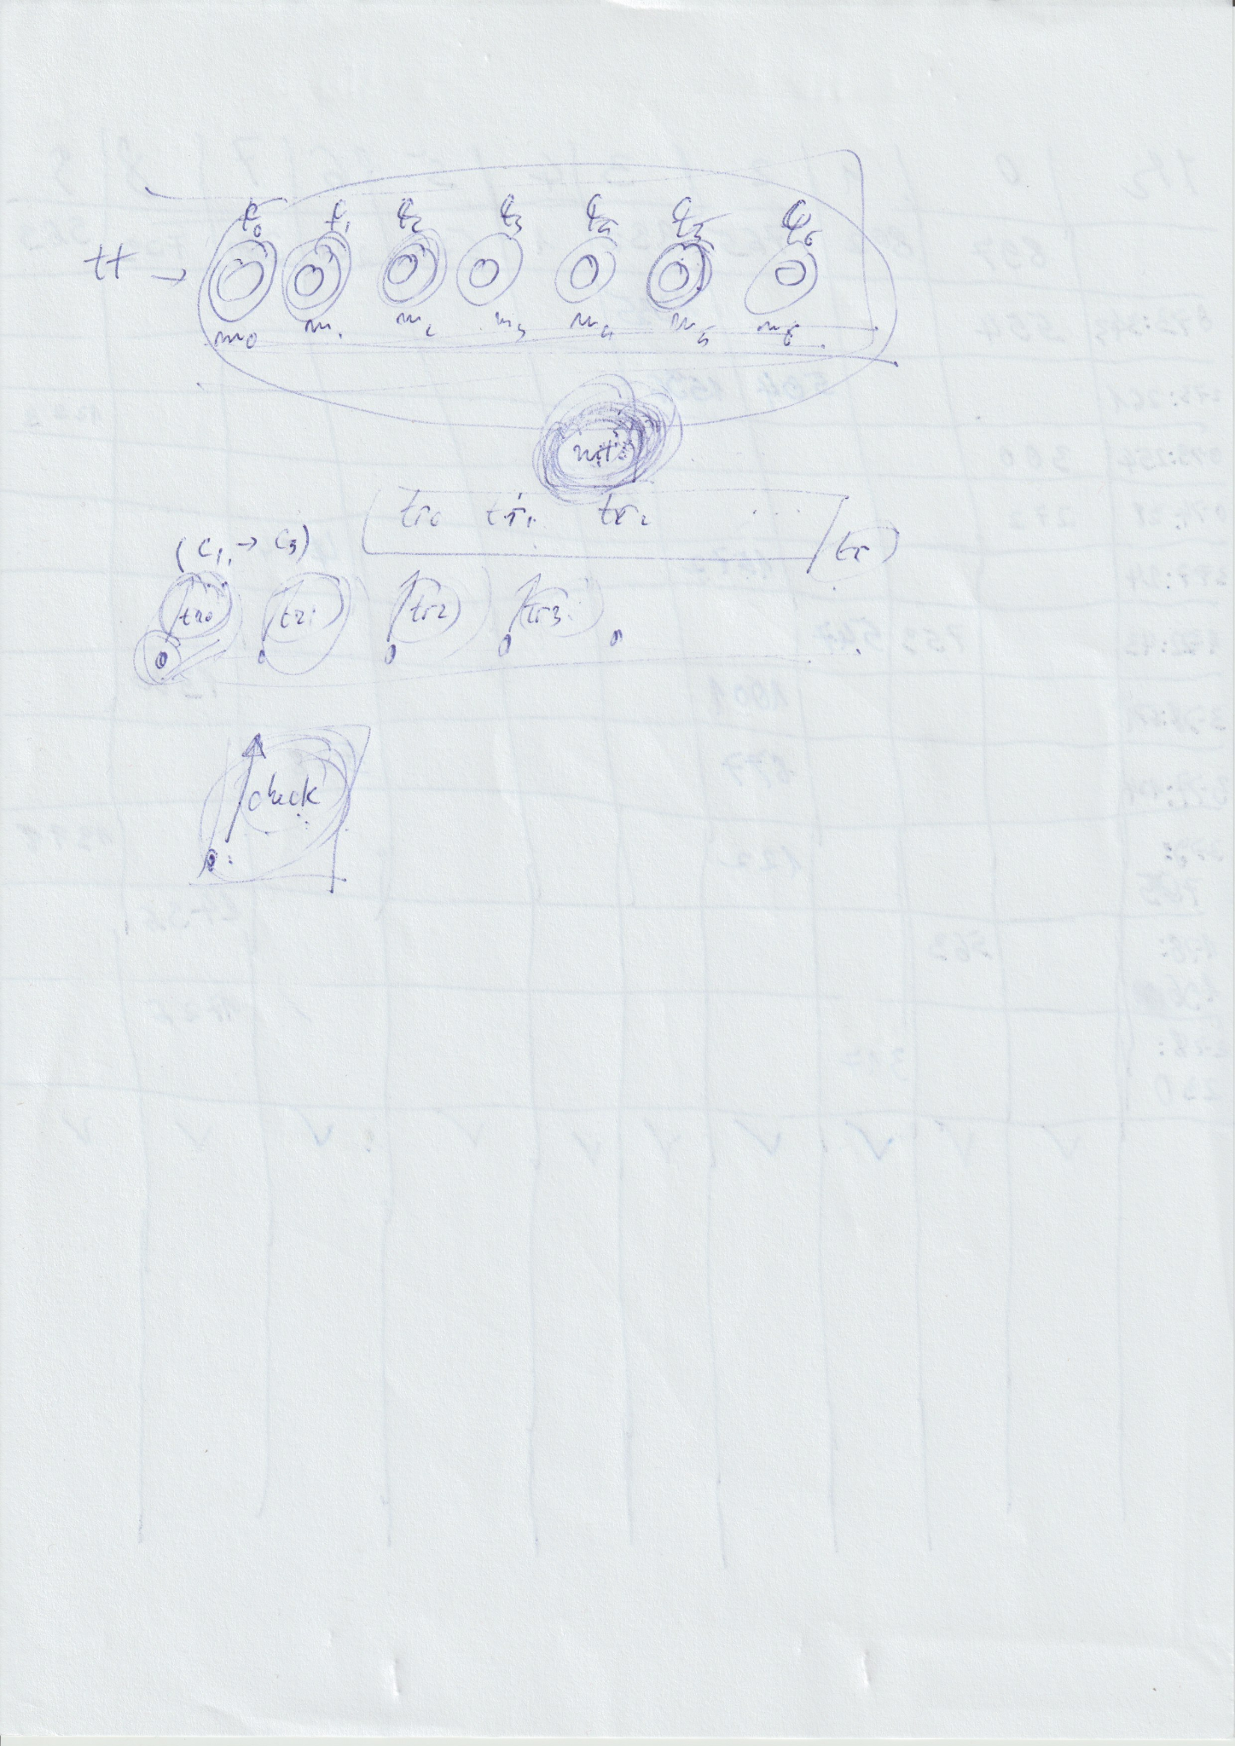

LAB W05
What are people looking for in a thesis? What are the expectations?

undergraduate exam consists of 3 parts
- theoretical contest - 3 big areas: OS, DB, DSA; on paper/oral
- the scientific paper of the thesis

scientific articles
scientific books
undergraduate thesis
dissertation thesis
doctorate thesis

question to your helper teacher: like how to find the bibliography

Gabi's way:
- initialState = 0 knowledge
- you find the problem you want to solve (ex: predict what players wins a chess game). it must be an open problem
- How did others tackle it?: through research
  - how do you explore anything that has been written on the topic? use AI. search a big space w/o a lot of time. GA balances exploration & exploitation
  - at 1st, you just explore (filter the water from the rivers and find nuggets => source of gold). How do you explore scientific work? Google related words to your topic in random order and add the word 'pdf' to the end
  - balancing with exploitation: harvest PDF files with the name: YEAR_KEYWORDS_VALUE, VALUE = enjoyment of reading 1 (crap) -> 5 (omg). you can even use real numbers
  - skimming articles: resemblance between scientific paper & Romanian's fairytail (basmul) - the chapters: introduction, intrigue (find a niche that can be improved/hasn't been tackled yet)/proposed approach/abstract, implementation, compare your performance on the problem vs the state of the art, conclusion - did we do something to improve?

comparing two architectures is a valid scientific paper

!!! you also need to put the shitty papers there. Why?

The Pareto principle - 80% of the wealth is owned by 20% of the population
extrapolating: 80% of the content on the topic is in the top 20% of it

golden tool: https://www.connectedpapers.com/

sqrt(n) splitting

winter break - free time to take the 20 papers and put a .docx in which you highlight main ideas, advantages, disadvantages. but you read everything

what is asked for the thesis: originality, no matter if it's basic

at the end of the paper highlight the disadvantages: conclusion & future improvements
THIS CHAPTER CONTAINS HINTS

??, adapt, improve

title: using <TECHNIQUE> to solve <PROBLEM>

for bachelor thesis, you need to show that you can create a layered architecture app

2 apps:
- deliverable intr-un REST API
- client care consuma API-ul

you need to convince that is motivational and relevant - it increases the quality of life

if you have a discussion, you have science

the app should show that you know you've been through all subjects

licenta poate sa fie personal project: git repo, documentatie, testare, layered architecture

LECTURE W5
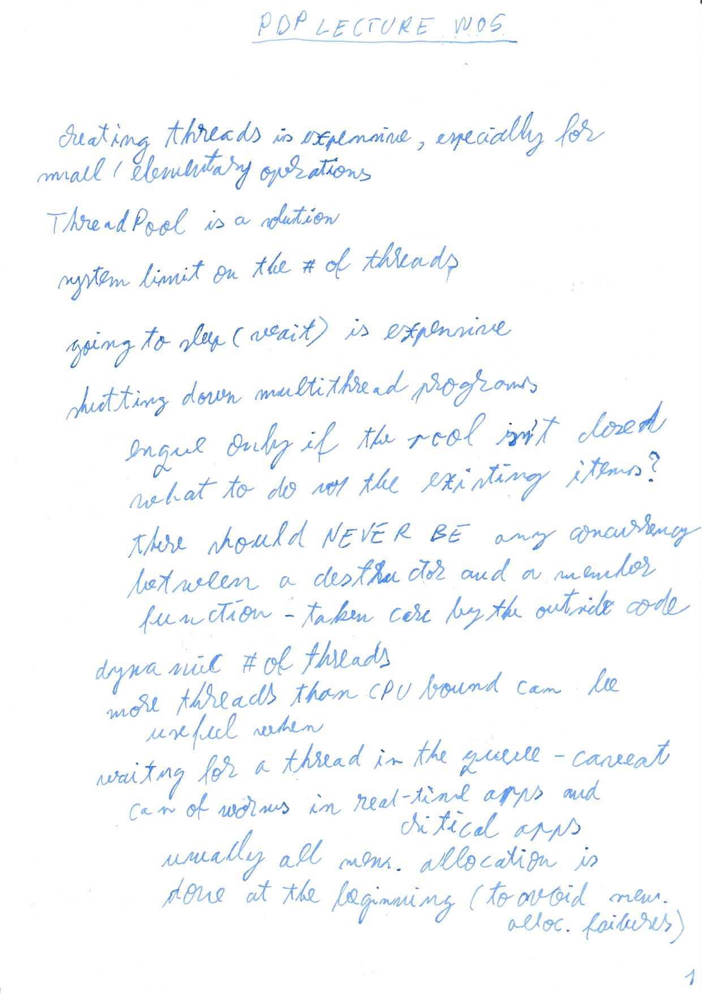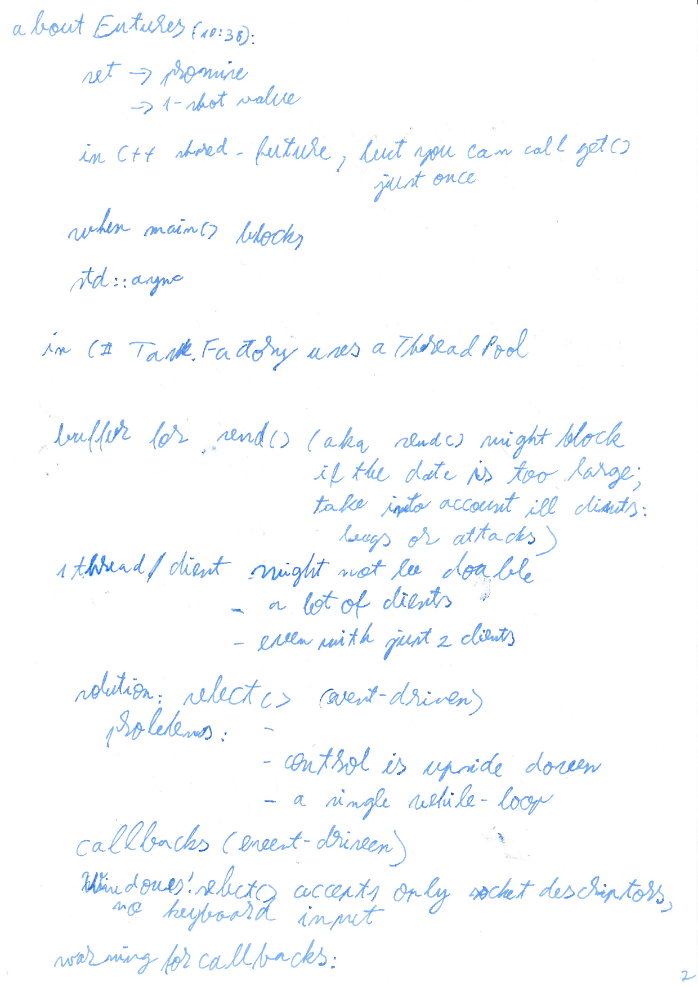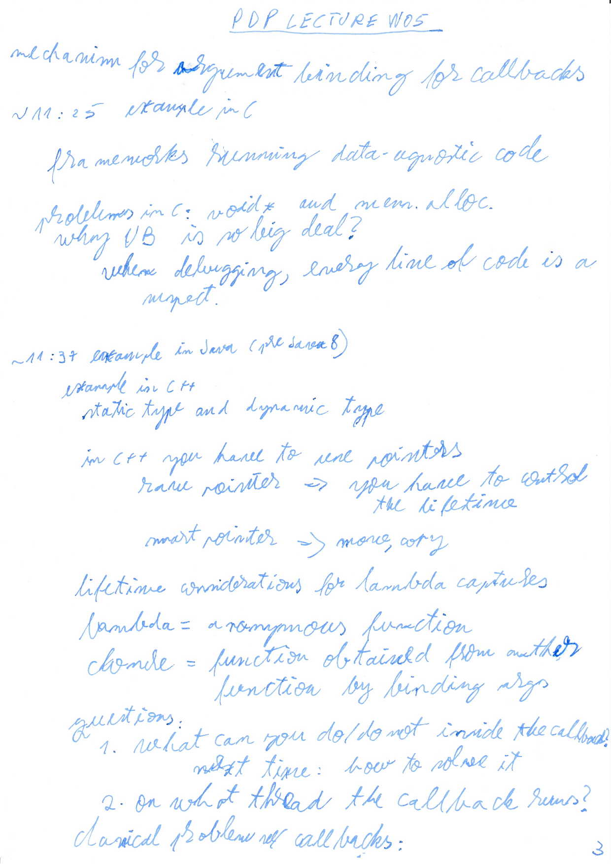

LECTURE W6
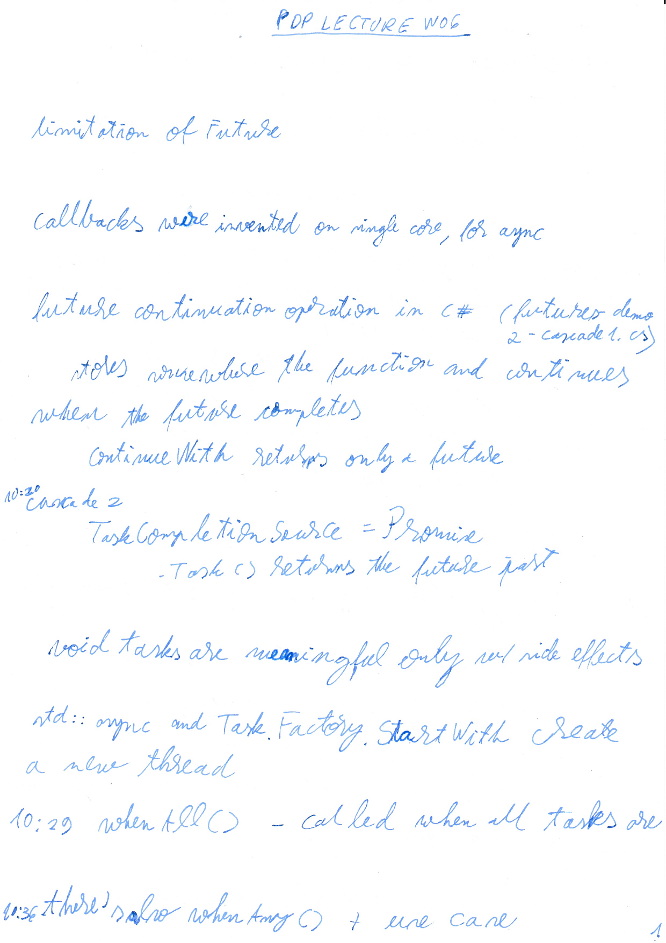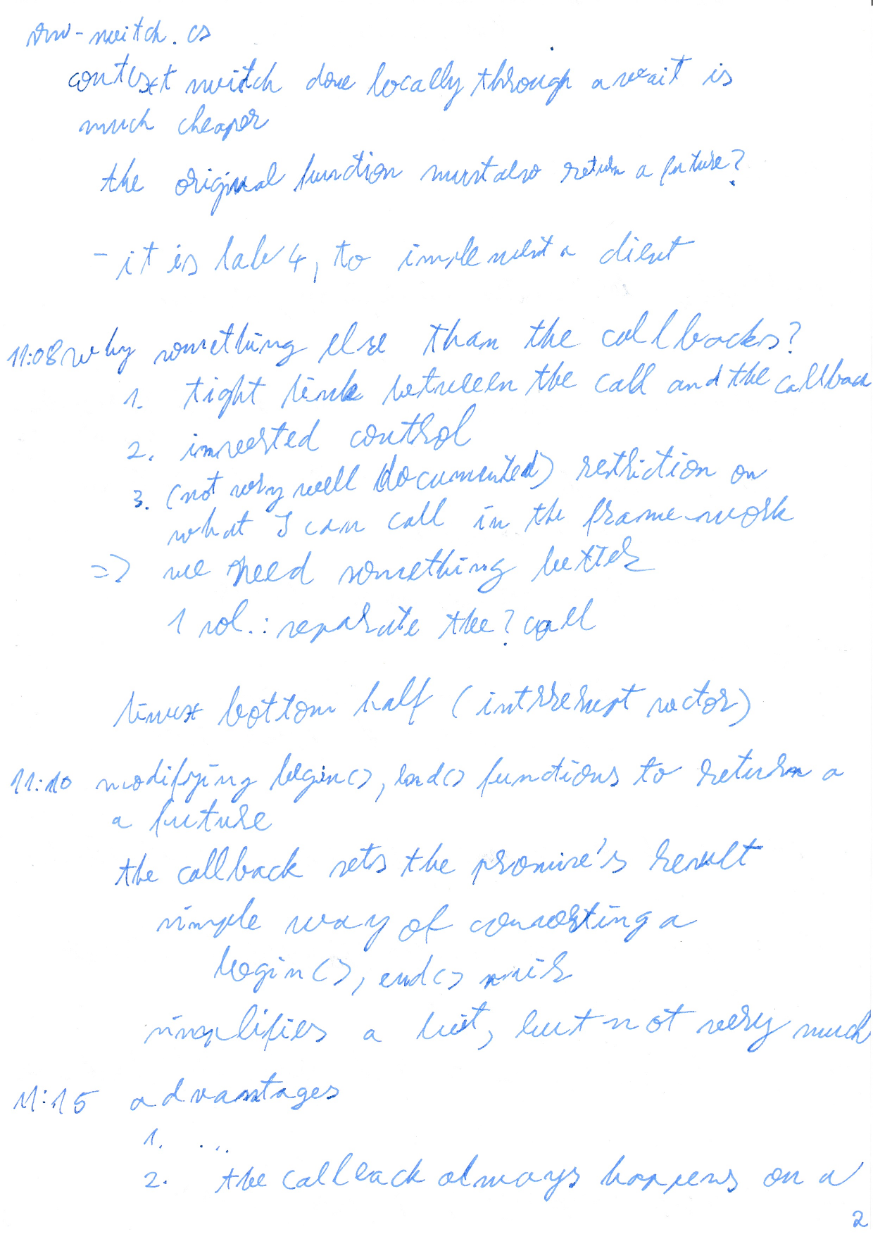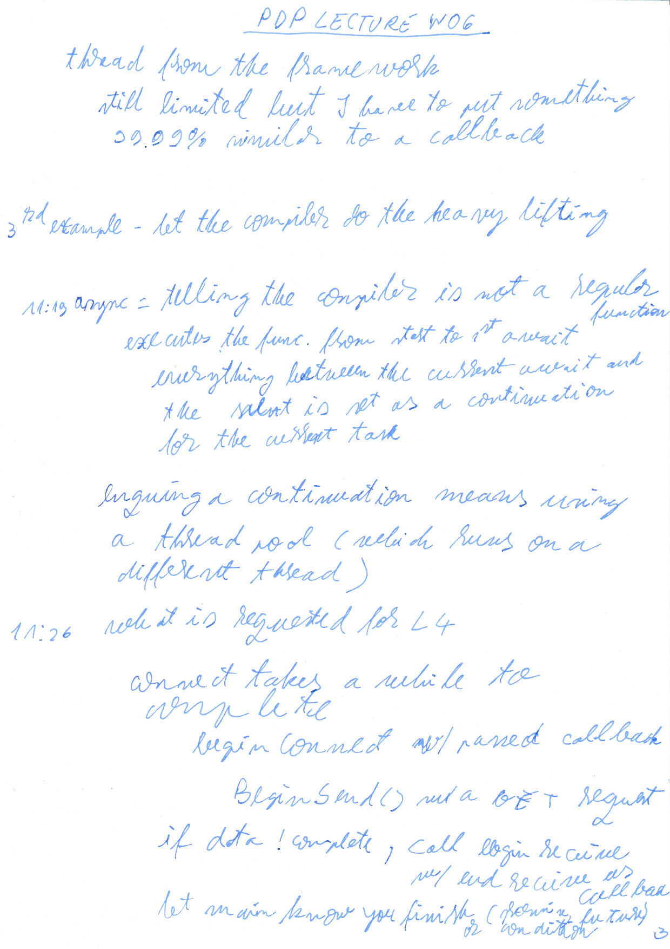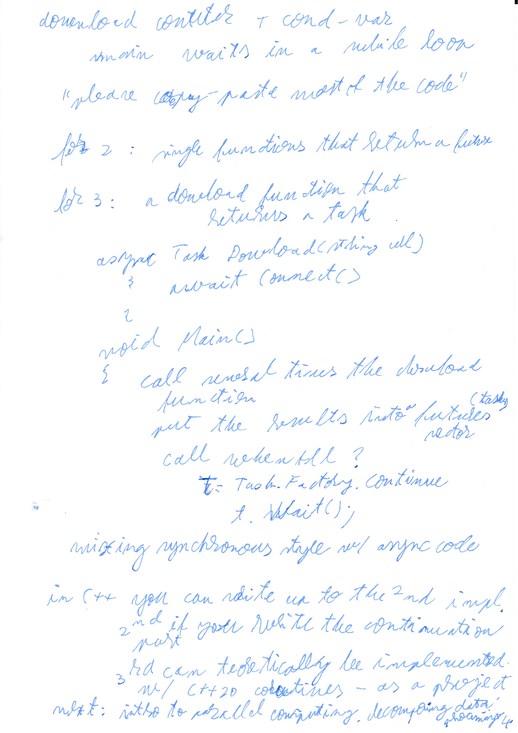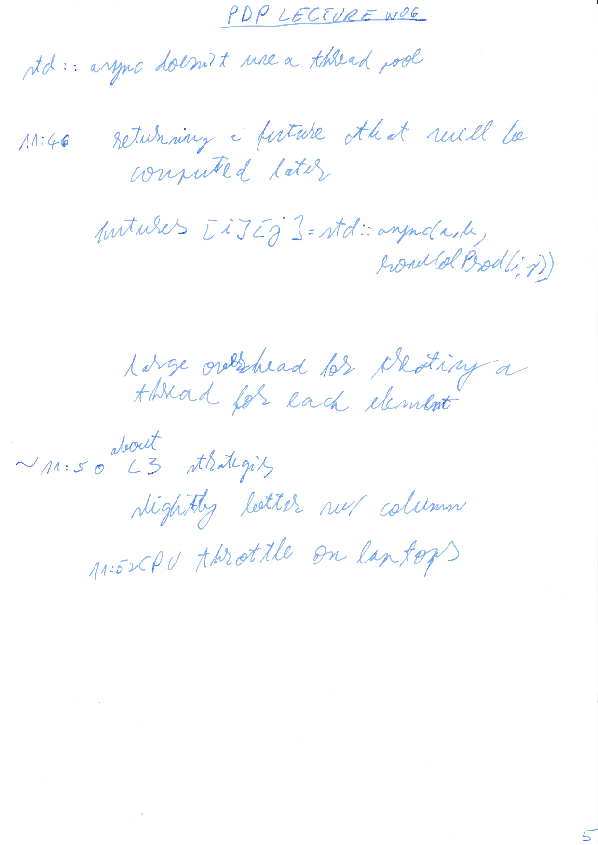

LAB W6
the IT Crowd

LECTURE W7
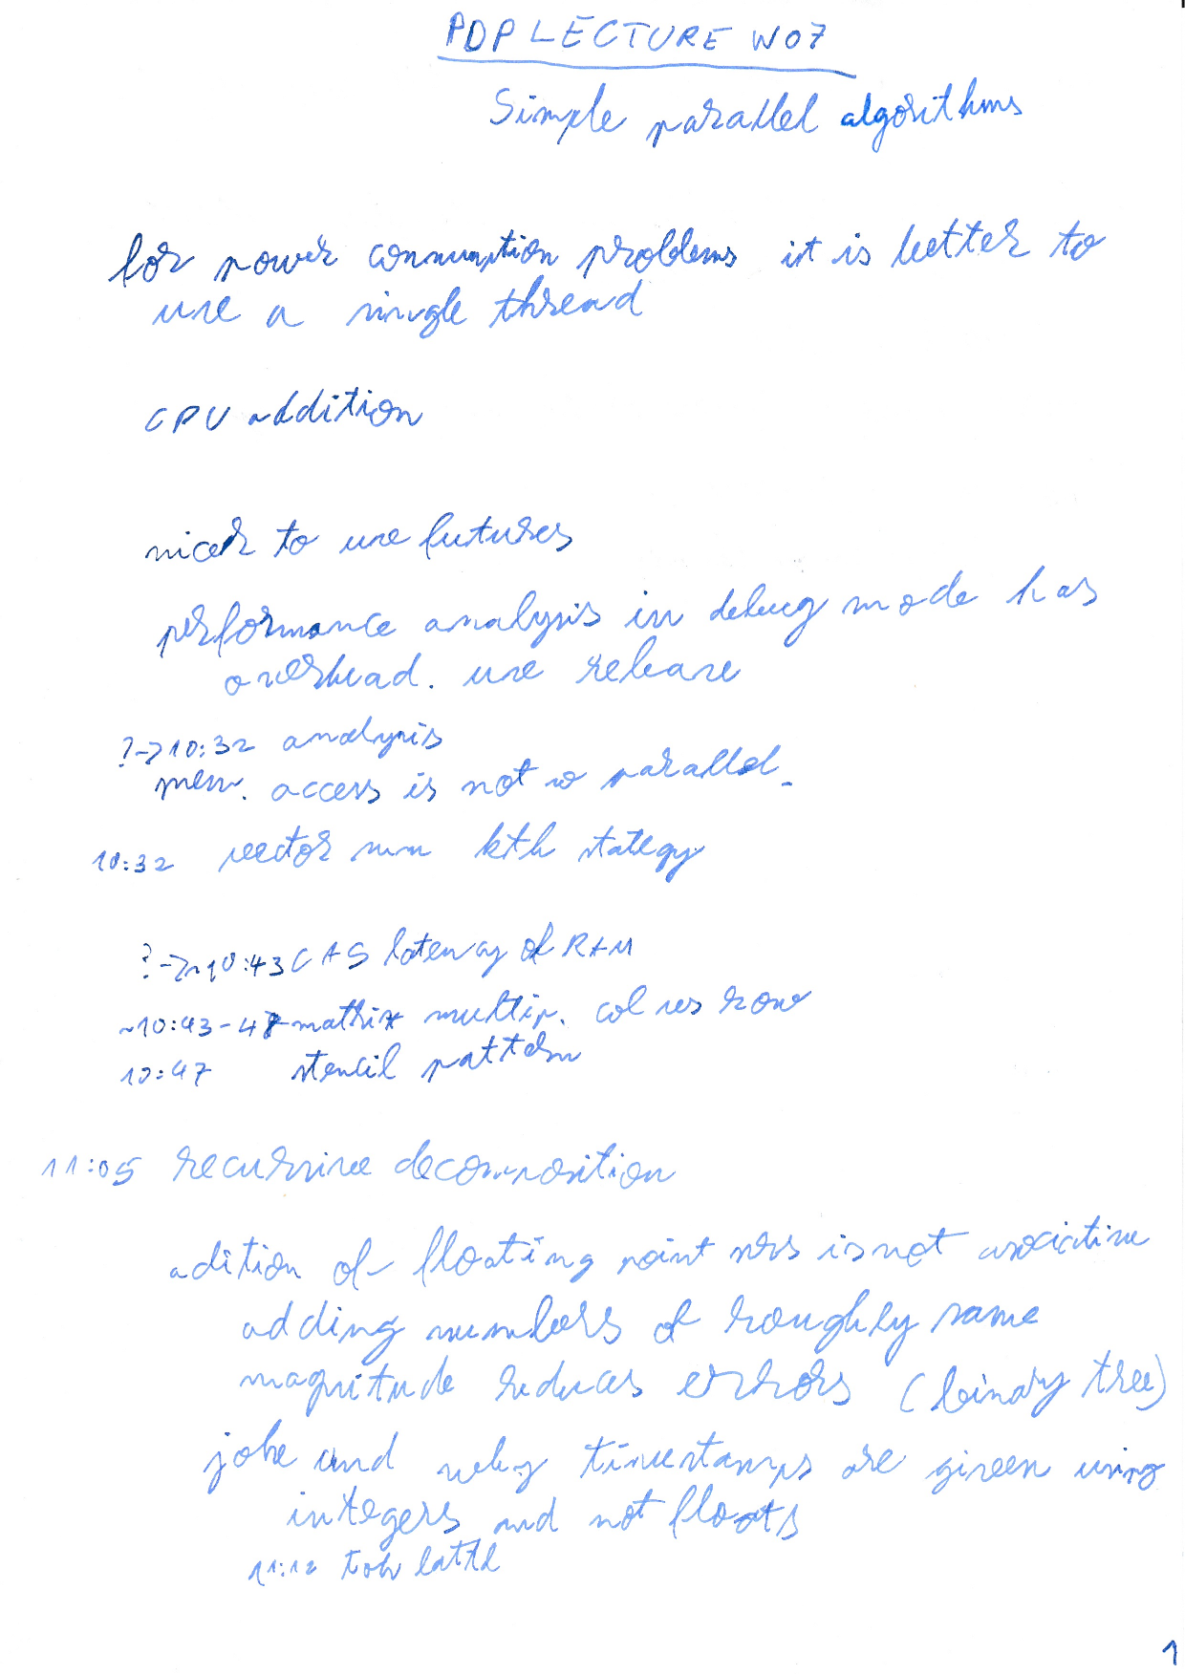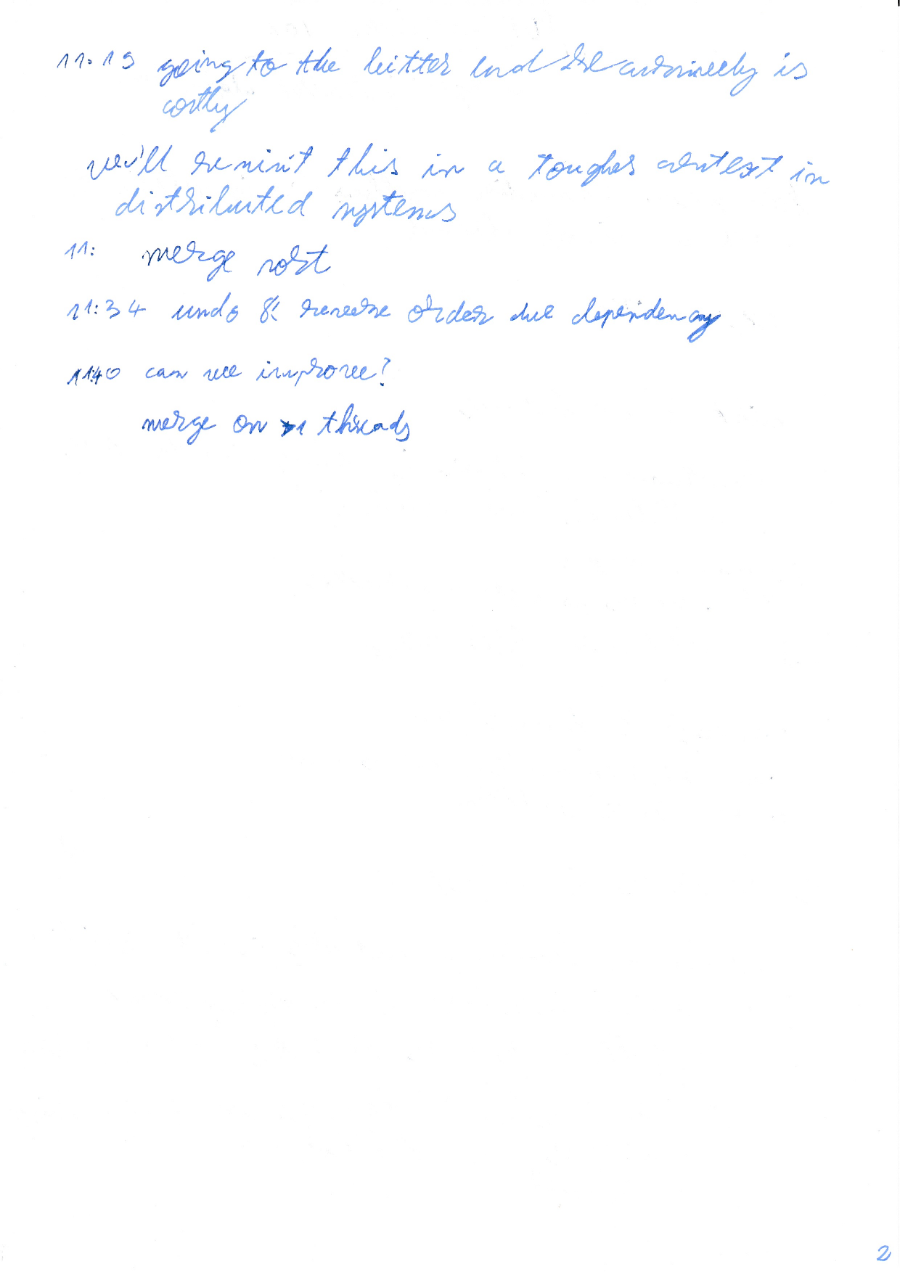

LECTURE W8
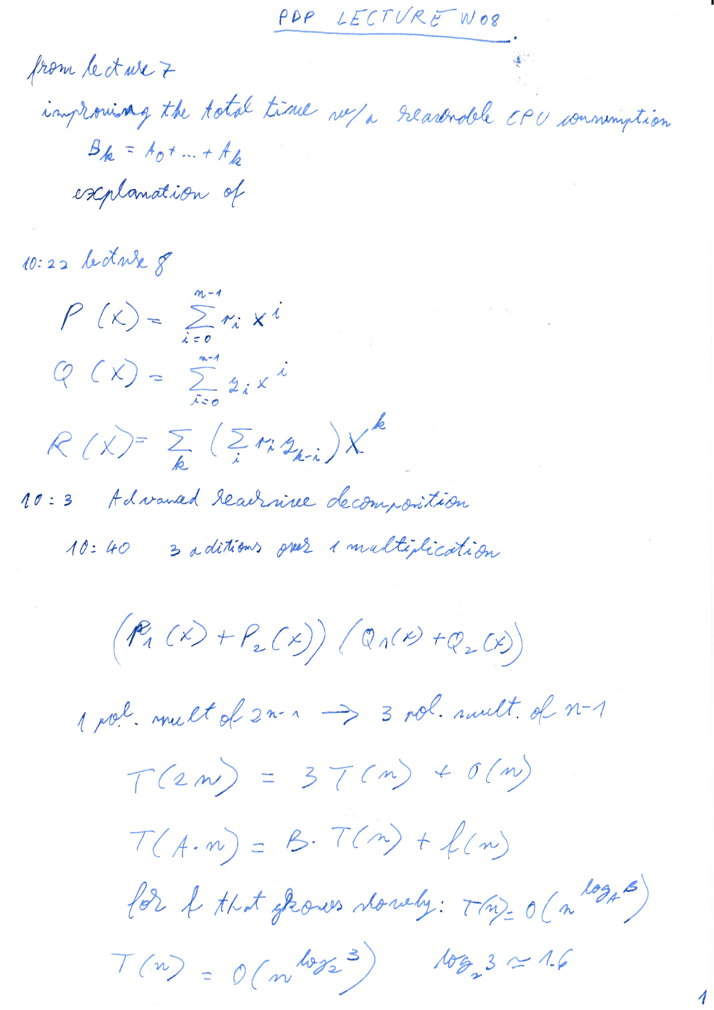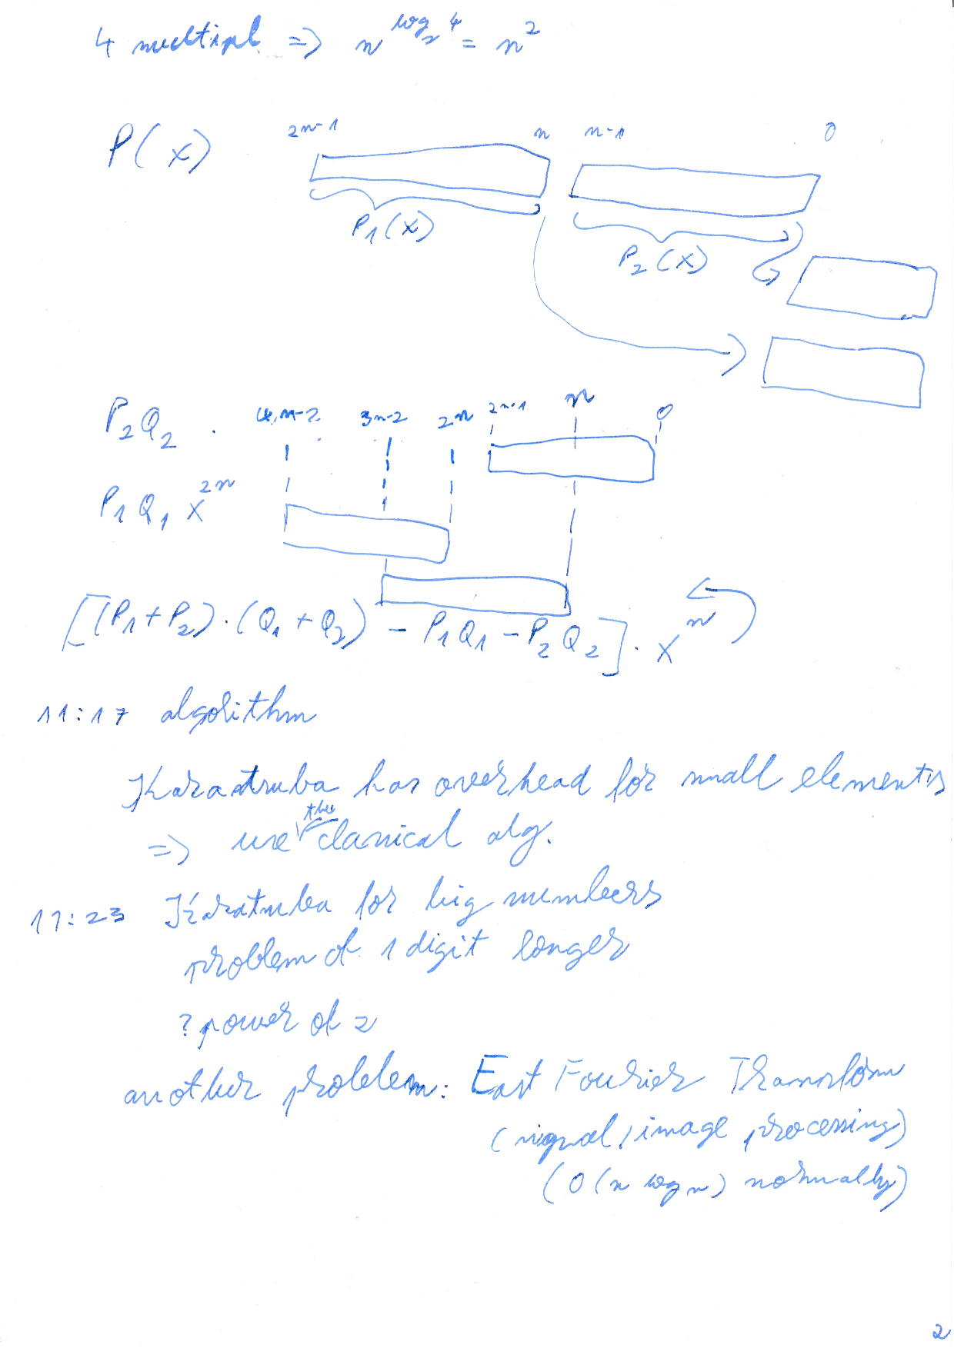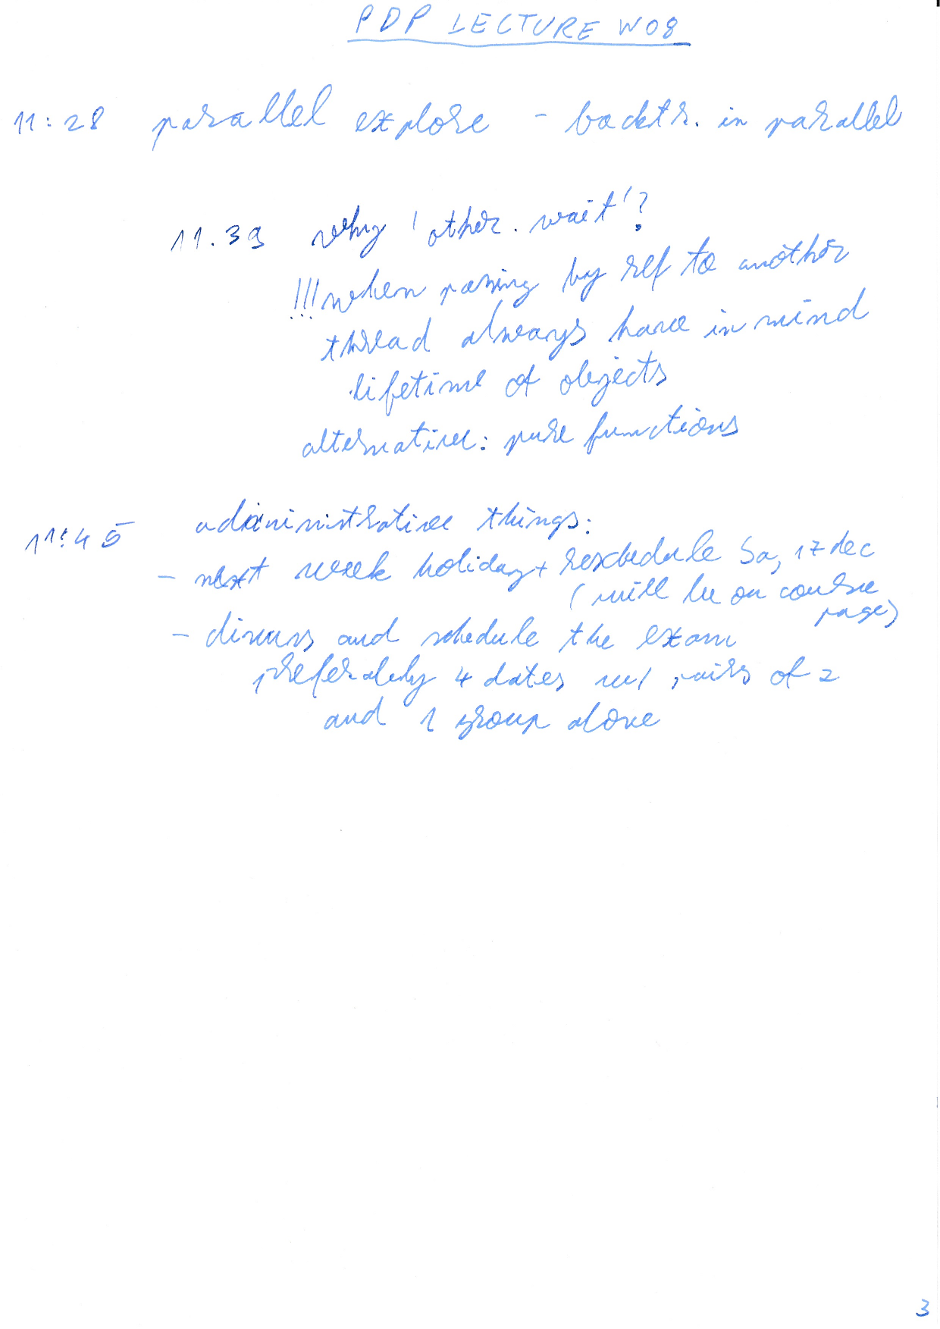

LECTURE W10 - MPI
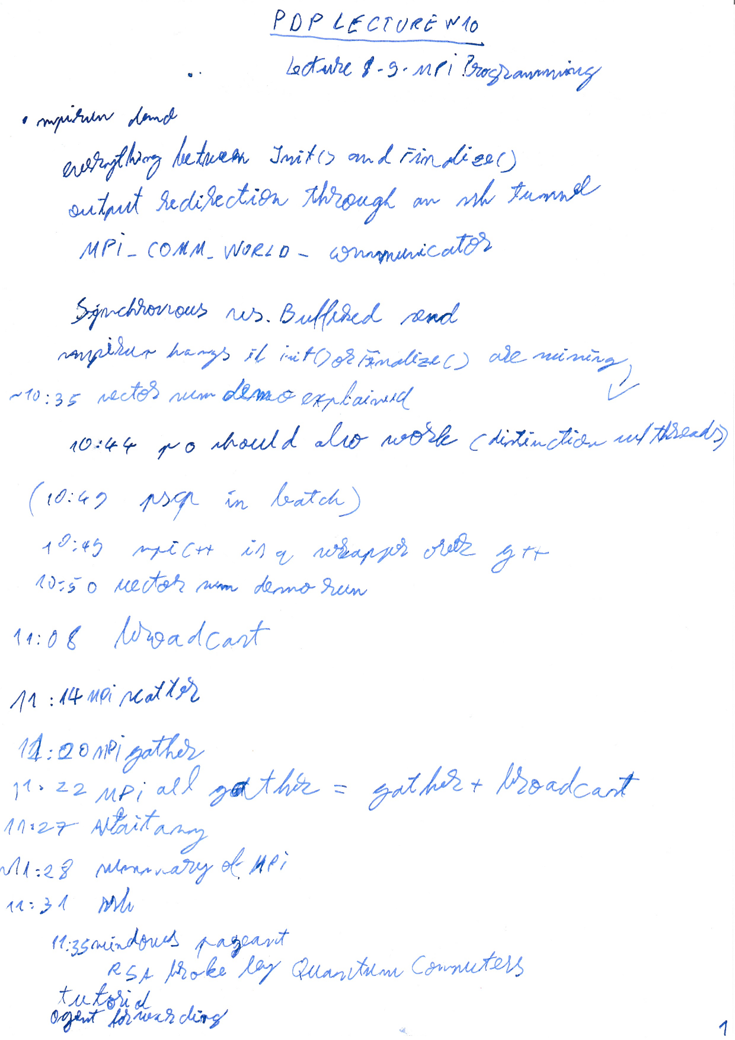

LECTURE W11
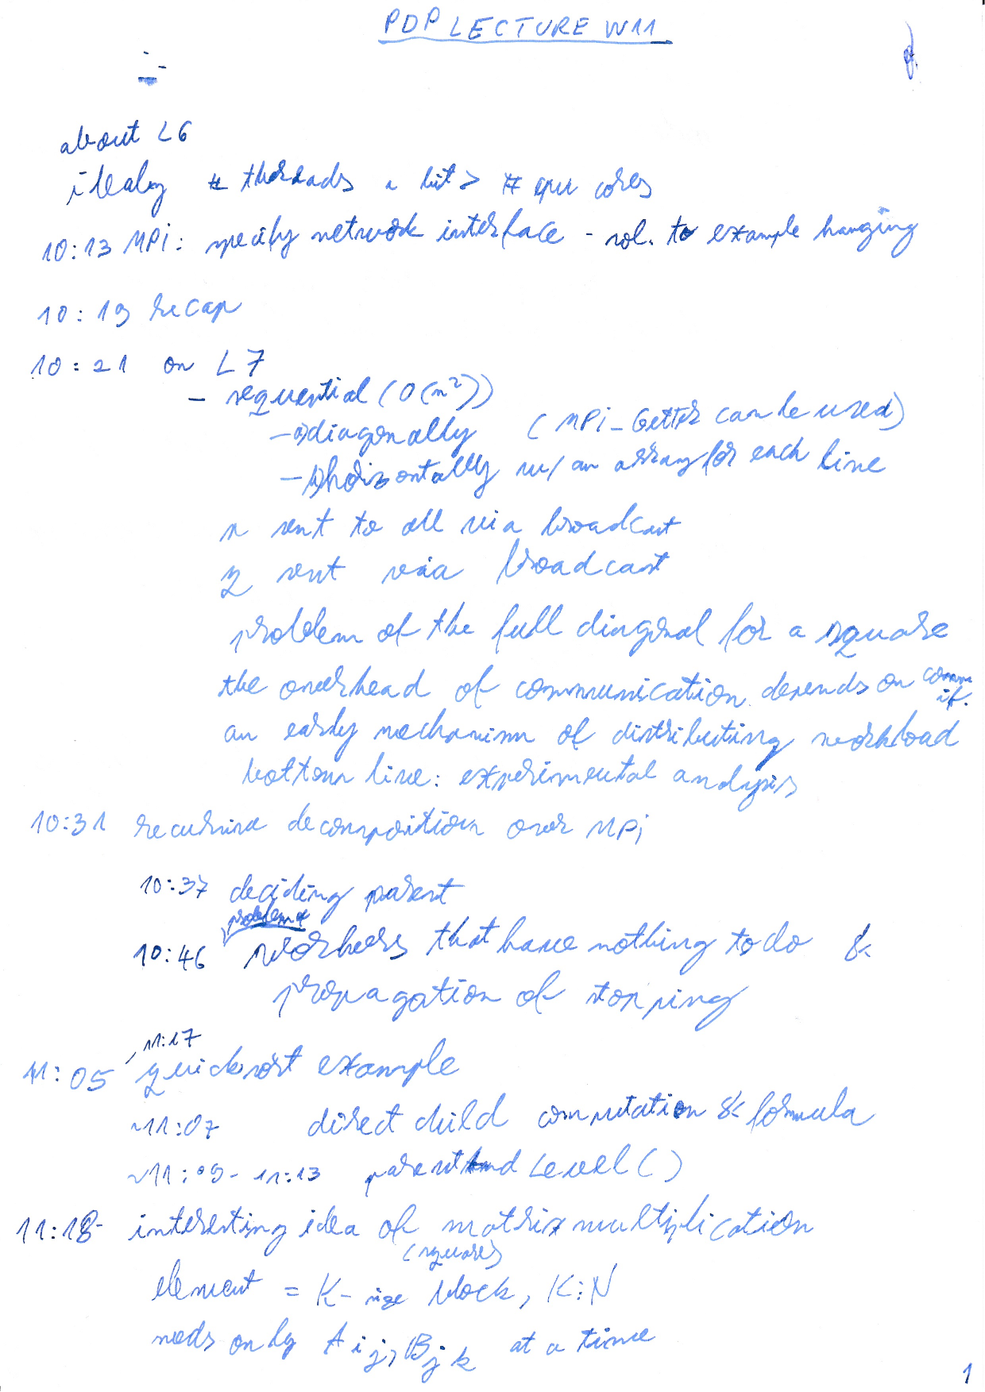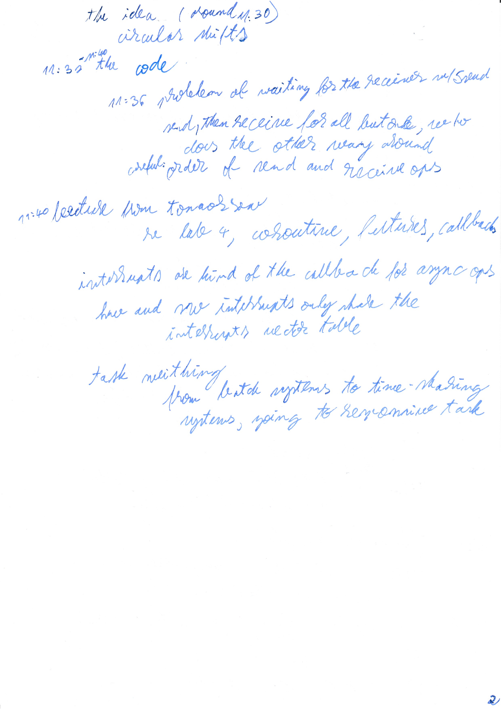

LECTURE W11 Recovery from W10
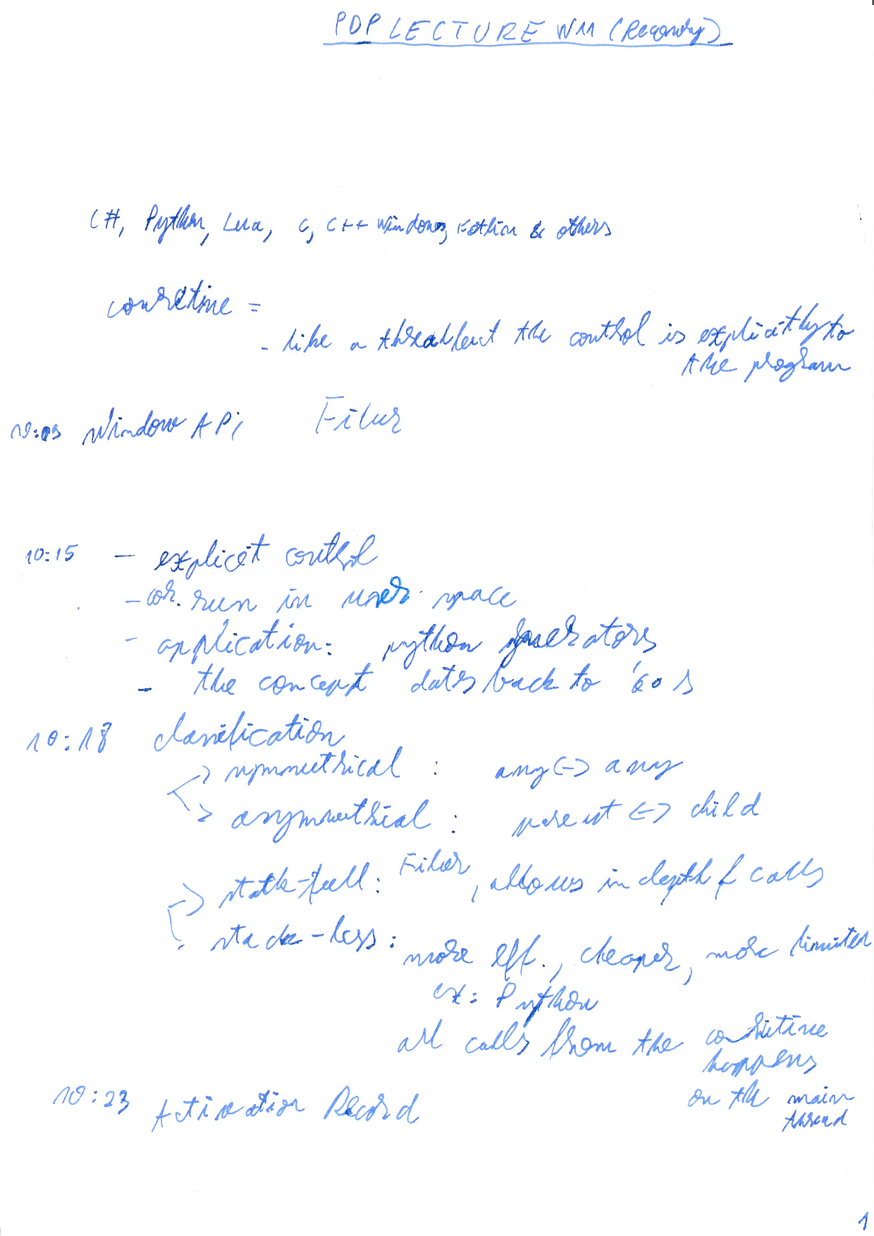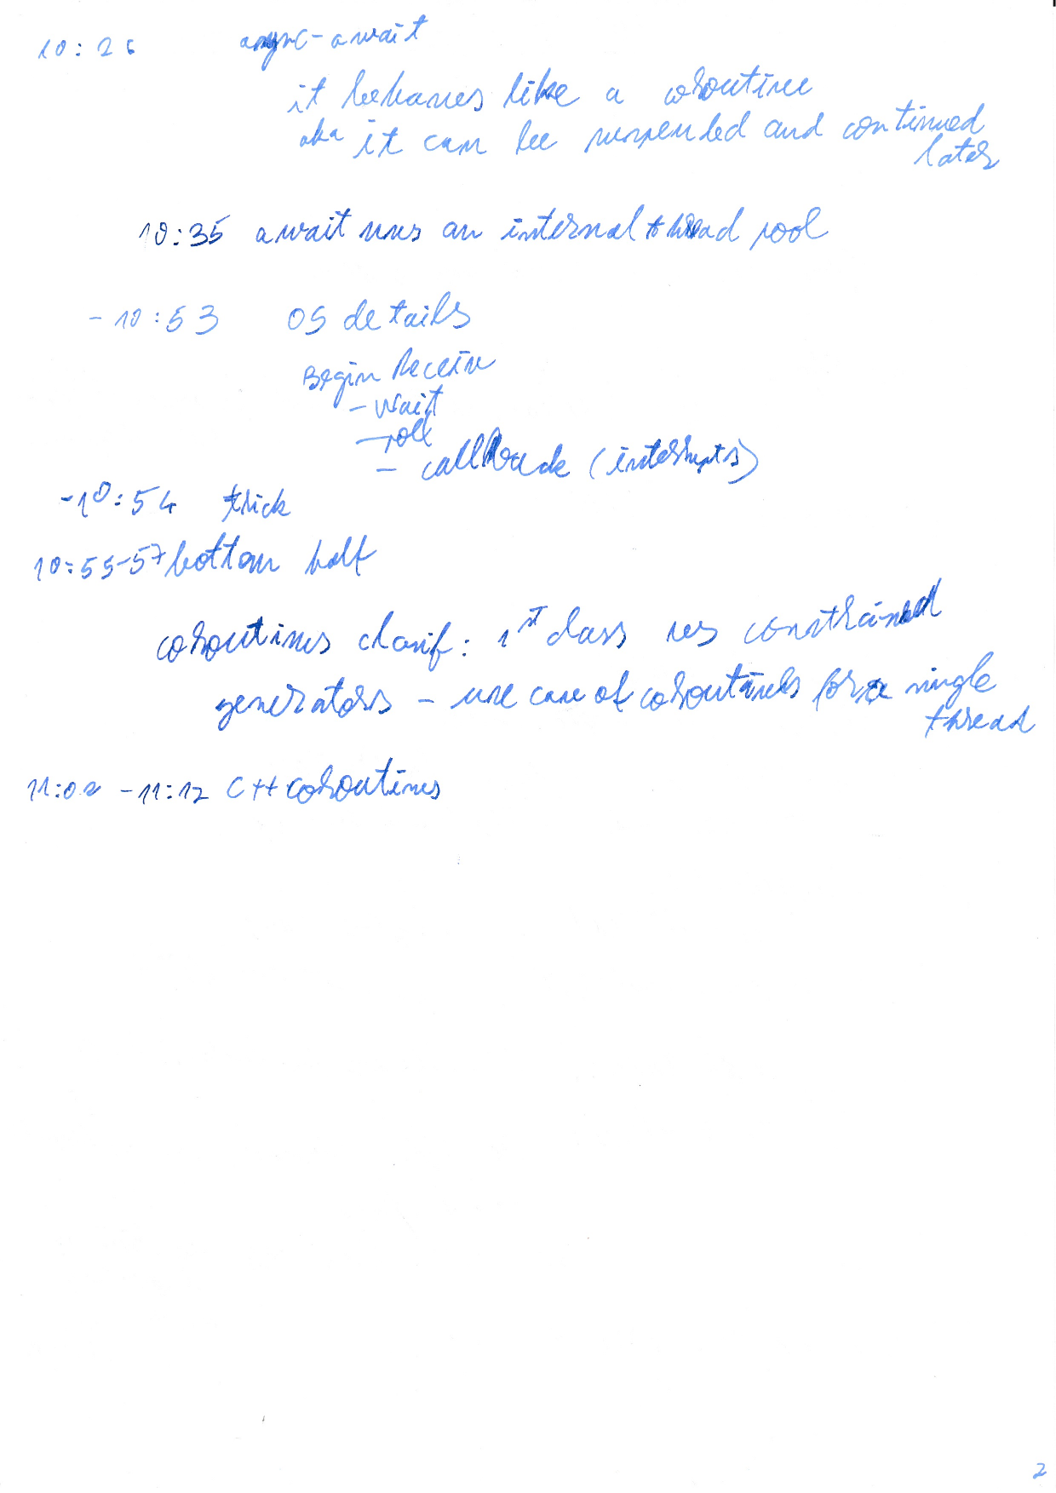

LAB W11

LECTURE W12
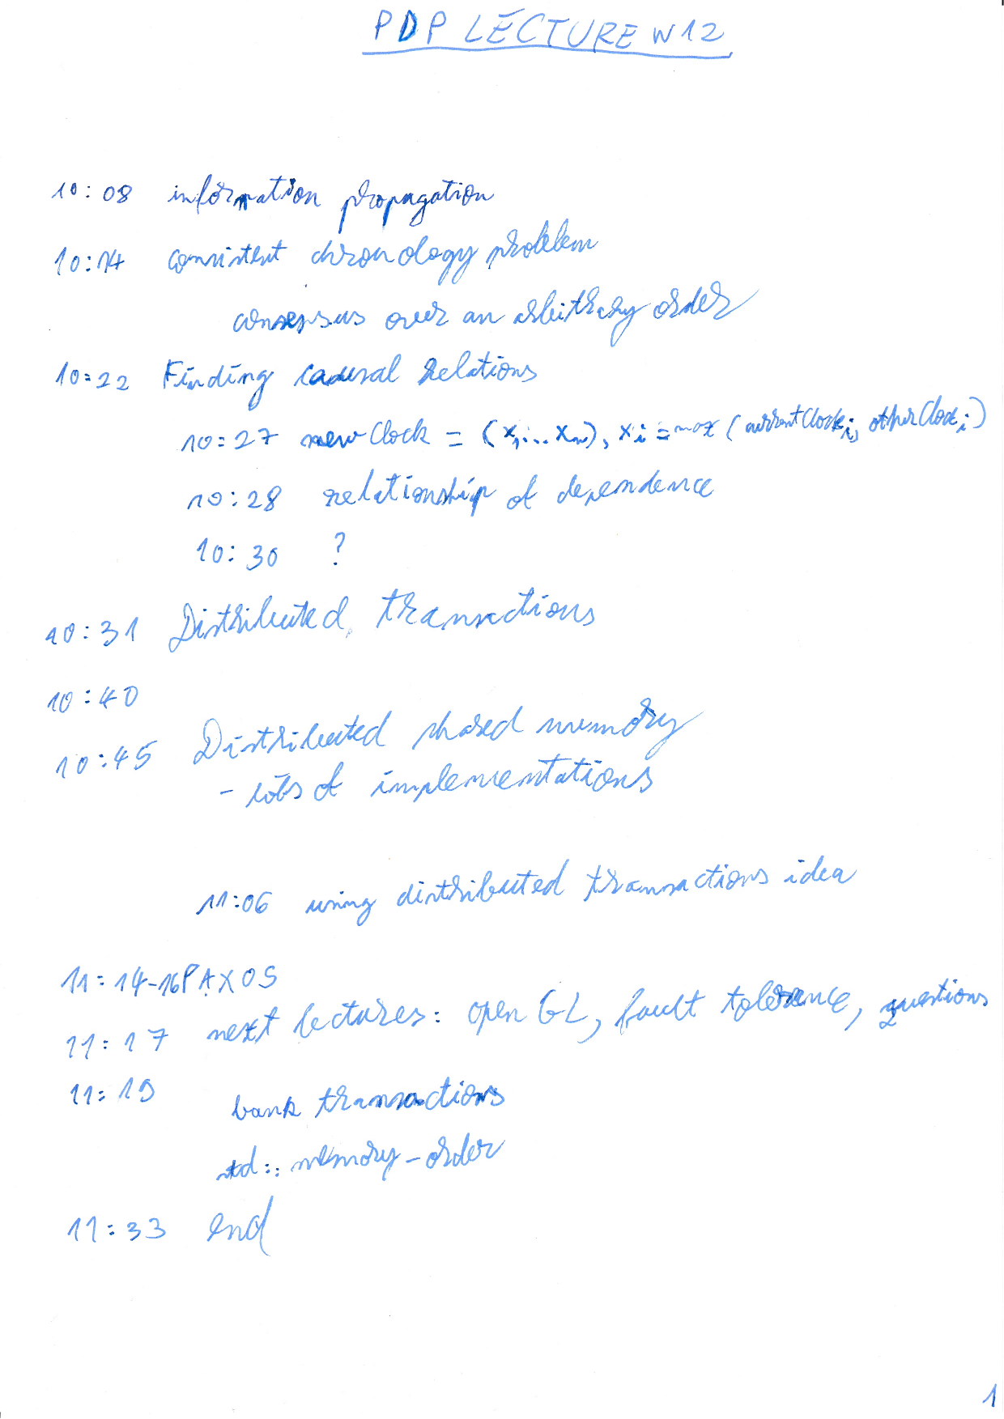

LECTURE W13 - OpenCL programming
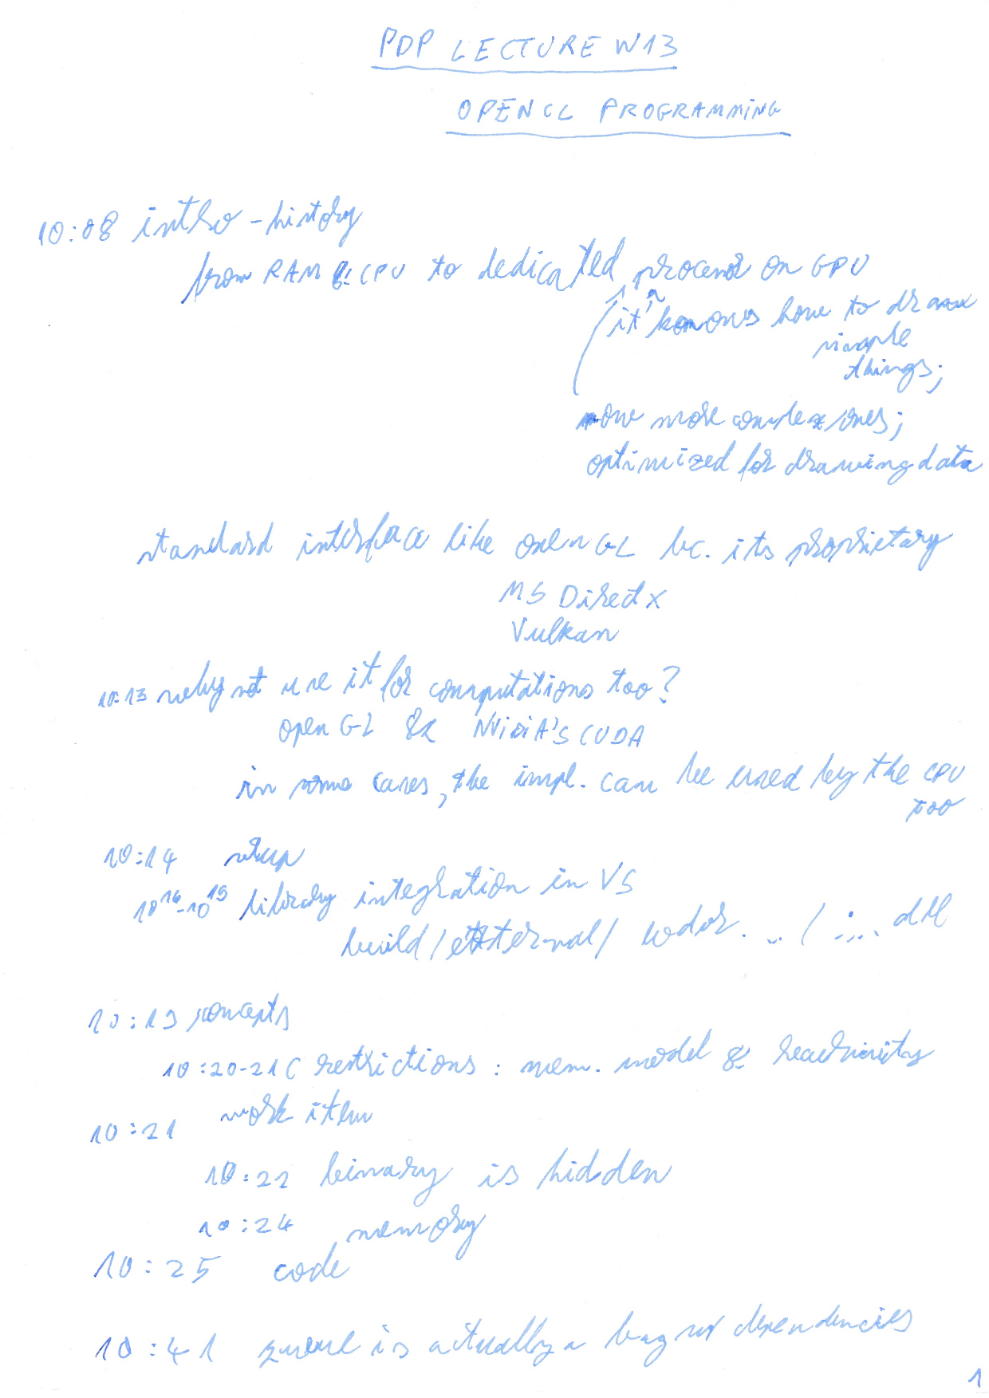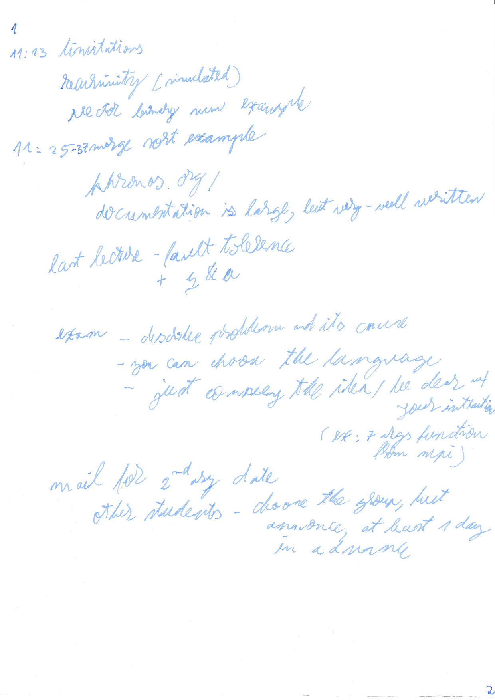

LECTURE W14 - Fault Tolerance
only scratching the surface, cuz the topic is huge

independence of airplane engines

case when redundancy didn't help cuz the software was the same - same error

manufacturing issue/overload
bottom line: failures are not always independent, software bugs will affect all devices that have the same software

10:14 consensus problem

advice: floating point arithmetics errors (associativity doesn't hold, casting to boolean, line example)

10:20 variations, General's problem

10:22 failure types

crash failure - best cuz it does not send bad data
byzantine failure - there could a traitor in the army, even the general
communication failure

10:26 sync vs async

no upper bound on computing time for async operations.

synchronous. if time limit is passed => process is considered faulty

no change of solving Consensu problem in the async case

sync case - byzantine failure

1 lieutenant failure
general failure

limit of 3t < n

all distinct => every1 sees distinct value => resort to the default value

timeout, you can create a default value for it

output does not uniquely depend on the output

why is the async case such a big deal?

deadline for non-leaf node that has a fault

puzzle: you have n prisoners. they are locked in individual sense (cannot communicate w/ one another).
from time to time, single prisoners are taken, arbitrarily, to the court. eventually, all prisoners will go.
communication device w/ 2 positions in courtyard. originally the switch is 0, the guardian doesn't touch it.
at an time, in a finite amount of time, a prisoner should be able to declare that all prisoners were in the courtyard
prisoners know the number n.

you have n prisoners switch https://jaylorch.net/brainteasers/ThePrisonersAndTheSwitch/

exam subjects - everything besides OpenCL
time: 2h
official cheats sheet A4 (aka 2 pages) that must be turned in at the end
retake exams has same rules and same difficulty

coming w/ another date - write an email

emphasis on parallel and distributed stuff and less on programming

∀ language, csharp, c++, java
he won't be picky w/ the syntax
don't exaggerate w/ the comments, try to be concise w/ the explanation

mutex, cond var, creation/joining of threads
but it's ok if you something else

recursive decomposition

always think about range of processors that are assigned to solve a particular problem

split the work and the range (ex: for karatsuba in 3)
pass the subproblem & the # of processors it can use

id formula: id_ind? = i + floor(nr_processs/2)

ex: mergesort-simplified-mpi.cpp

get parent id - from status param of MPI_Recv()

from binary tree:
childId1 = parent * 2;
childId2 = parent * 2 + 1;
works only if the parent doesn't do anything. but this means the parent idles

solution to the problem:
2 prisoners case
3 prisoners case
idea
?
3 declares only if he sees in pos 0 after he saw it in pos 1
fault - taking the prisoners always in the order 1, 2, 3

rules to satisfy by ∀ algorithm
- not output an incorrect result (partial correctness)
- eventually output a result

hash table based mapping

probability of 0 (ex: always flipping heads)

probability of 0 for infinite loop for a fair random generator for generating edges in a graph

1 prisoner becomes the counter, all others flip the switch to pos 1 the 1st time they see it.
the counter flips it to pos 0, if it's in pos 1

exam prep 07 feb
cheat sheet writing idea: write on paper, scan it, make it smaller, print it, now u got free space

Astea sunt toate variantele posibile pe care le poate da la ppd? (normal sau cu mpi)
1. big_numbers_product
2. scalar_product_simple
3. scalar_product_tree
4. convolution
5. hamiltonian
6. permutations
7. combinations
8. k_combinations
9. k_coloring
10. merge_sort
11. quick_sort
12. producer_consumer

resources
- lectures
- bookmarks?
- https://github.com/alexovidiupopa/pdp/tree/main/exam-workspace/src/ro/alexpopa/mpi
- exam-subjects 2022
- study session Jinga 4 feb
  - problem 1
    - 00:00 intro
    - 03:08 A fals?
    - 06:40 B adv
    - 09:05 C
    - 1?:??
  - 33:22 problem 2
  - ~53 - about problem 3
  - problem 1
  - 1:09:10 problem 2 ProducerConusmerQueue
  - 1:21:59 sub 4 pr 1

subject 2
- https://www.cs.ubbcluj.ro/~rlupsa/edu/pdp/progs/futures-demo1-with-impl.cpp
- https://www.cs.ubbcluj.ro/~rlupsa/edu/pdp/progs/producer-consumer.cpp
- https://www.cs.ubbcluj.ro/~rlupsa/edu/pdp/exam-example.pdf future with continuation

cheatsheets
- cheat sheet pdp.pdf by Cristian Gherman

2023 subject 2 problem 1
Consider the following excerpt from a program that is supposed to merge-sort a vector. The function worker() is called in all processes except process 0, the function mergeSort() is called from process 0 (and from the places described in this excerpt), the function mergeSortLocal() sorts the specified vector and the function mergeParts() merges two sorted adjacent vectors, given the pointer to the first element, the total length and the length of the first vector.

void mergeSort(int* v, int dataSize, int myId, int nrProc) {
if (nrProc == 1) {
mergeSortLocal(v, dataSize);
} else {
int halfLen = dataSize / 2;
int halfProc = (nrProc+1) / 2;
int child = myId+halfProc;
MPI_Ssend(&halfLen, 1, MPI_INT, child, 1, MPI_COM_WORLD);
MPI_Ssend(&halfProc, 1, MPI_INT, child, 2, MPI_COM_WORLD);
MPI_Ssend(v, halfSize, MPI_INT, child, 3, MPI_COM_WORLD);
mergeSort(v+halfSize, halfSize, myId, nrProc-halfProc);
MPI_Recv(v, halfSize, MPI_INT, child, 4, MPI_COMM_WORLD, MPI_STATUS_IGNORE);
mergeParts(v, dataSize, halfSize);
}
}

void worker(int myId) {
MPI_Status status;
int dataSize, nrProc;
MPI_Recv(&dataSize, 1, MPI_INT, MPI_ANY_SOURCE, 1, MPI_COMM_WORLD, &status);
auto parent = status.MPI_SOURCE;
MPI_Recv(&nrProc, 1, MPI_INT, parent, 3, MPI_COMM_WORLD, MPI_STATUS_IGNORE);
std::vector v(dataSize);
MPI_Recv(v.data(), dataSize, MPI_INIT, parent, 3, MPI_COMM_WORLD, MPI_STATUS_IGNORE);
mergeSort(v.data(), dataSize, myId, nrProc);
MPI_Ssend(v.data(), dataSize, MPI_INT, parent, 3, MPI_COMM_WORLD);
}

Which of the following issues are present? Describe the changes needed to solve them.

A: the application can deadlock if the length of the vector is smaller than the number of MPI processes.

B: the application can produce a wrong result if the input vector size is not a power of 2.

C: some worker processes are not used if the number of processes is not a power of 2.

D: the application can deadlock if the number of processes is not a power of 2.

EOF

